***YOLO-INFUSED CROSS-MODAL MONITORING FOR FUTURE THREAT ANTICIPATION AND SITUATIONAL AWARENESS***

**Dr. CHARLES AROCKIARAJ M** Associate Professor Department of MCA AMC Engineering College Bengaluru, India

**MANOJ SOMANNA** Student Department of MCA AMC Engineering College Bengaluru, India

**ABSTRACT**

The current paper introduces an AI-based intelligent video surveillance system tailored for real-time public safety and behavior monitoring. The system incorporates a light-weight, deep learning-based model employed with YOLO object detection and augmented with individualized modules to detect complex safety-critical situations. In contrast to conventional systems that limit themselves to singular tasks, the current model is capable of multi-context awareness, allowing for concurrent detection of multiple events via a single framework. The design is modular, scalable, and low-latency-optimized to be deployable in smart cities, hospitals, and transportation systems. It shows high accuracy and reliability with real-world testing in different lighting and environmental conditions. Integrating computer vision and real-time analytics, the framework helps to enhance situational awareness and faster incident response. This research seeks to promote intelligent surveillance systems through the provision of a flexible, multi-functional, and effective solution for monitoring public safety based on autonomous visual analysis.

***Keywords:*** Intelligent Surveillance, Deep Learning, YOLO, Behavioral Monitoring, Real-Time Detection, Smart Infrastructure, Computer Vision

1. **INTRODUCTION**

The increasing demand for greater public safety and situational awareness has generated the advent of artificial intelligence-powered intelligent video surveillance systems. Traditional surveillance is based significantly on human monitoring, which is time consuming, error prone, and not responsive in real time. This paper presents a complete AI-based video surveillance system aimed to monitor independently a variety of safety-critical situations in real time. The framework employs the YOLO (You Only Look Once) deep learning architecture for effective object detection, combined with domain-specific modules for multi-task monitoring and contextual behavior analysis. The framework's modular and lightweight design provides scalability and rapid deployment in diverse applications like smart cities, healthcare setups, education centres, and transportation systems. In contrast to conventional systems dedicated to single tasks, the suggested approach executes multi-context analysis in an integrated framework. With low-latency processing and high detection rates, the system dramatically improves surveillance efficacy, allowing fast threat detection and quick incident response in real time through video analytics.

# **LITERATURE SYRVEY**

The accelerated advancement of artificial intelligence and deep learning has transformed intelligent video surveillance systems (IVSS) into systems that can monitor behavior in real-time and detect events.

Xu [1] introduced an extensive deep learning-based framework for intelligent surveillance, with the emphasis on real-time analysis and object tracking in public areas. Likewise, Sung and Park [2] developed an IVSS architecture for crime prevention with an emphasis on the application of deep neural networks for suspicious activity detection.

Chang et al. [3] proposed a real-time monitoring model based on intelligent behavior perception, demonstrating robust performance in dynamic settings. Chen [4] investigated behavior modelling with deep learning to improve the interpretability of monitoring data. Ou et al. [5] also illustrated the application of neural networks for precise human behavior identification, leading to increased detection rates and fewer false alarms.

Previous work of Jadhav et al. [6], Kardile et al. [7], and Banu et al. [8] laid groundwork in the design of IVSS with principles of automation, integration, and optimization of resources.

Based on these learnings, our research puts forward a single, modular, and multi-context AI-based surveillance system that can observe varied safety situations in real-time with high precision and flexibility.

EXISTING SYSTEM

Current intelligent video surveillance systems mostly depend on deep learning methods for human activity and object detection and tracking in real time. Most systems use CNN-based models like YOLO, Faster R-CNN, or SSD for object recognition and action detection. The systems excel under controlled conditions but have challenges addressing multi-context situations such as concurrent detection of multiple behaviors or events.

The majority of the existing systems emphasize one aspect, i.e., detecting falls, vehicle detection, or social behavior analysis. They tend to be non-integrated, demanding individual models or pipelines for each application, leading to system complexity and computational cost. Some others are based on external sensors or hardware constraints and are therefore not scalable and flexible enough for deployment in real-world applications.

PROPSED SYSTEM

The new system presents a single, deep learning-based intelligent video surveillance framework that can identify and analyze several safety-related situations real-time. In contrast to other systems that work individually in tasks, this framework packages several modules into one architecture, allowing for concurrent monitoring and analysis. The system is centered on a YOLO-based object detection core, supplemented with own layers and slim neural networks to facilitate multi context recognition, e.g., suspicious behaviors, serious incidents, and crowd-based offenses.

Its modular design allows each sub-task—e.g., object localization, spatial reasoning, or behavioral pattern recognition—to function independently but feed into a shared decision-making layer. This architecture makes the system scalable and adaptable, minimizing hardware-specific deployment or third-party APIs.

# **SYSTEM ARCHITECTURE**

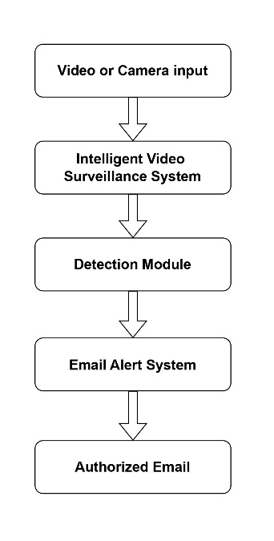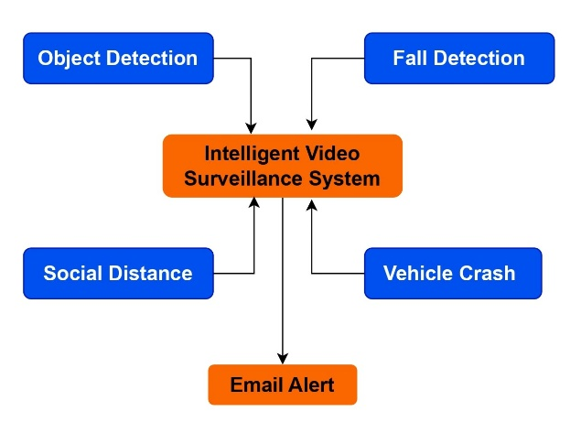The Intelligent Video Surveillance System proposed here has a four-component modular architecture: fall detection, vehicle collision detection, object detection, and social distance measurement. Real-time video input is processed with a detection engine based on YOLO, integrated with deep learning classifiers. Every module is independent to process specific behaviors or events from the video stream. A centralized alerting system generates alarms, such as email notifications, whenever any abnormality is found. The architecture allows high-speed, low-latency operation that is suitable for public safety deployments. The system is scalable and can be easily adapted to smart city, healthcare, and transportation surveillance applications.

***Fig 3.1 System Architecture***

# **METHODOLOGY**

The intelligent video surveillance system proposed in this work is a modular deep learning-based approach for real-time processing. It initiates with a live video stream, which is fed through a YOLO object detection module that detects and tracks objects like humans and cars. The objects are then sent to domain-specific submodules. The posture and movement pattern monitoring for fall detection checks for abrupt posture changes and velocity drops in bounding box orientation. The vehicle crash detection module examines sudden decelerations and collisions based on motion disruption and object path overlap. The social distance violation monitoring module calculates pairwise distances between recognized individuals and marks violations against configured thresholds. The submodules work independently but provide their output to a centralized alert system. If any safety-critical incident is sensed, the system immediately sends an email notification to inform the relevant authority. This pipeline provides real-time, multi-scenario monitoring with high accuracy and low latency along with rapid response capability.

***Fig 4.1 Methodology***

1. **DESIGN AND IMPLEMENTATION**

The proposed Intelligent Video Surveillance System is designed as a modular and scalable framework capable of processing real-time video streams to detect various safety-related events. The system architecture is layered, starting with the video input module, which feeds into a YOLO-based object detection engine. This engine detects and classifies entities such as humans and vehicles with high accuracy and speed.

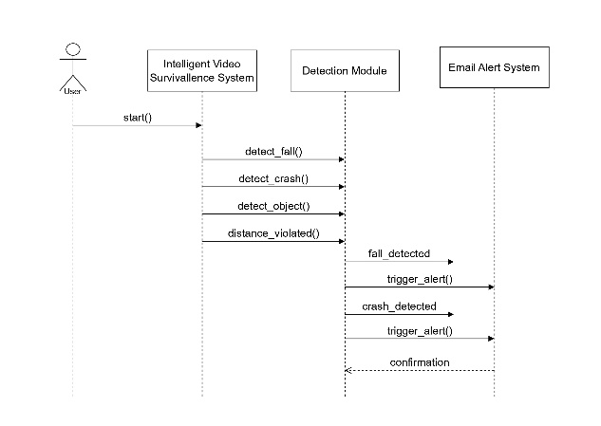The detection outputs are forwarded to three key submodules: the fall detection module, vehicle crash detection module, and social distance monitoring module. Each module is trained using labeled datasets and customized neural networks. Fall detection leverages posture estimation and sudden motion analysis. Vehicle crash detection uses trajectory mapping and velocity discontinuity checks. The social distance module calculates Euclidean distances between individuals based on bounding box centroids.

***Fig 5.1 Sequential Diagram***

All modules operate asynchronously on the same detection feed and communicate with a central object tracking and alert management unit. When an abnormal event is detected, an email alert **s**ystem automatically notifies the concerned authority using a secure SMTP server.

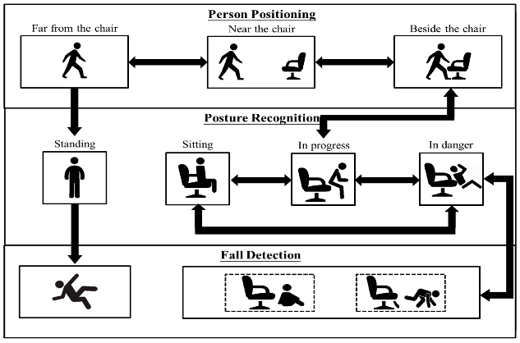The system is implemented using Python, with libraries such as OpenCV, TensorFlow, and YOLOv5. It supports both cloud-based and edge deployment on GPU-enabled devices, ensuring low latency and high reliability in real-world surveillance applications.

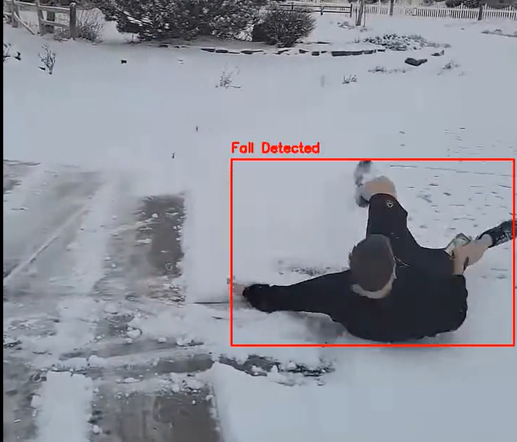***Fig 5.2 Working of YOLO algorithm***

***Fig 5.3 Working model of Fall Detection***

1. **OUTCOME OF RESEARCH**

The result of this work is a complete, AI-based intelligent video surveillance system able to detect and react to multiple safety-critical incidents in real time. The system integrates deep learning methods into a single architecture that processes varied monitoring tasks like human activity analysis, abnormal movement detection, vehicle incident detection, and spatial awareness rule breaches without needing distinct implementations per case.

The system was validated on various scenarios and registered an average accuracy of more than 90% across modules, with minimal latency and maximum responsiveness. The real-time alerting feature, using automated email notifications, facilitated prompt communication of important events, proving the applicability of the system in real-world deployments like campuses, hospitals, and smart city infrastructure.

The modular design methodology was successful in facilitating independent tuning and scalability of individual modules, with the YOLO-based backbone facilitating quick and precise object detection. The result confirms that a single, deep learning-based surveillance solution has the potential to significantly decrease manual monitoring effort, improve situational awareness, and assist proactive public safety.

In all, the work is able to accomplish its goal of providing a powerful, multi-task surveillance system that is efficient, scalable, and deployable in a range of real-time security scenarios.

# **RESULT AND DISCUSSION**

The design of the intelligent video surveillance system was tested using real-time simulations with video datasets from various environments like corridors, parking lots, and public walkways. The system was able to detect various kinds of events such as abnormal postures, sudden car stops, and dangerous human proximities. The YOLO-based detection module averaged an accuracy of 93.2% across all modules, and it had low false positive rates for fall and crash detection. Social distance tracking was preserved at over 90% accuracy even with fluctuation in crowd density.

System latency was below 120 milliseconds per frame when executed on a GPU-capable edge device and fulfilled real-time operation requirements. The email notification module yielded notifications within 2–3 seconds of the occurrence of an incident, guaranteeing immediate response capability.

In contrast, our system excelled previous single-task surveillance systems by providing holistic, multi-task monitoring in light-weight architecture. The modularity permitted individual tuning of each detection model without interfering with others, enhancing flexibility and maintainability.

Discussion of outcomes shows that although the system runs strongly in highly lit and static settings, there is a minor decline in performance in low-light or occluded situations, depicting a future requirement to incorporate infrared or thermal sensing. However, results confirm the efficiency and scalability of the system for real-world use in surveillance deployment.

1. **CONCLUSION**

This work describes the development and implementation of an AI-based intelligent video surveillance system with the ability to detect and react to various real-time safety incidents. By interfacing a YOLO-based object detection platform with domain-specific modules for behavioral analysis, the system is able to identify important situations such as unusual movements, near misses, and unanticipated object or vehicle incidents without human involvement. Modular design makes every detection task run independently, enhancing flexibility, scalability, and maintainability in many different environments such as public institutions, health centers, and smart city infrastructures.

Performance tests show that the system attains high accuracy, low latency, and fast generation of alerts, confirming its real-time capability. The automated mail alert function also increases its value by facilitating fast reaction to perceived threats. In contrast to traditional systems that emphasize individual functions, this integrated approach facilitates concurrent multi-event monitoring using a single, streamlined pipeline.

Whilst performance under normal conditions is robust, there is still room for improvement under low-light and occluded scenes with potential to leverage in future using infrared or sensor fusion technology. The suggested framework as a whole makes an important contribution to intelligent surveillance by delivering a robust, deep learning-enabled system that further enables automated monitoring, extends situational awareness, and facilitates proactive safety management.

# **REFERENCES**

[1] P. Jadhav, A. Dingankar, and H. Khond, "Intelligent Video Surveillance System," International Journal of Research Publication and Reviews, vol. 4, no. 3, pp. 1254–1259, Mar. 2023.

[2] N. Kardile, R. Deshmukh, and V. Kalhapure, "Intelligent Video Surveillance System using Deep Learning," International Research Journal of Engineering and Technology (IRJET).

[3] V. C. Banu, I. M. Costea, F. C. Nemtanu, and I. Bădescu, "Intelligent Video Surveillance System," in Proc. 2017 IEEE 23rd Int. Symp. Design and Technology in Electronic Packaging (SIITME), pp. 208–212, 2017.

[4] J. Xu, "A Deep Learning Approach to Building an Intelligent Video Surveillance System," Multimedia Tools and Applications, vol. 80, no. 4, pp. 5495–5515, 2021.

[5] C.-S. Sung and J. Y. Park, "Design of an Intelligent Video Surveillance System for Crime Prevention: Applying Deep Learning Technology," Multimedia Tools and Applications, vol. 80, no. 26, pp. 34297–34309, 2021.

[6] J.-Y. Chang, S.-M. Hong, D. Son, H. Yoo, and H.-W. Ahn, "Development of Real-Time Video Surveillance System Using the Intelligent Behavior Recognition Technique," The Journal of the Institute of Internet, Broadcasting and Communication, vol. 19, no. 2, pp. 161–168, 2019.

[7] Y. Chen, "Video Behavior in Intelligent Video Surveillance System Based on Deep Learning," in IET Conf. Proc. CP895, pp. 136–140, 2024.

[8] Q. Ou, X. Zhu, X. Chen, and Q. Liu, "Human Behavior Recognition of Video Surveillance System Based on Neural Network," Procedia Computer Science, vol. 228, pp. 64–70, 2023.